**PIZZA SALES SQL QUERIES:**

1. Total Revenue:

SELECT SUM(total_price) AS Total_Revenue from pizza_sales

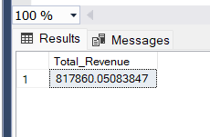

1. Average Order Value

SELECT SUM(total_price) / COUNT(DISTINCT order_id)as Avg_Order_value from pizza_sales

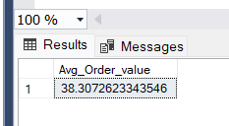

1. Total Pizza Sold:

SELECT SUM(quantity) AS Pizza_sold from pizza_sales

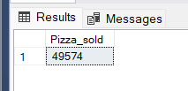

1. Total orders:

SELECT COUNT(DISTINCT order_id) as Total_orders from pizza_sales

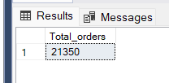

1. Average pizza per order:

SELECT CAST(CAST (SUM(quantity) AS decimal(10,2))/ CAST(COUNT(DISTINCT order_id)AS decimal(10,2)) AS DECIMAL (10,2))AS AVERAGEPIZZA_ORDER from pizza_sales

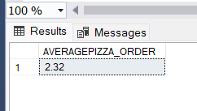

1. Daily Trend for Toal order:

SELECT DATENAME(DW,order_date) as order_day, COUNT(DISTINCT order_id) AS Total_orders from pizza_sales GROUP BY DATENAME(DW,order_date)

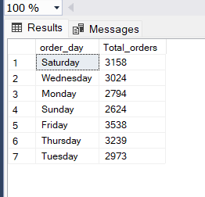

1. Monthly trend for total orders:

SELECT DATENAME(MONTH,order_date) as month_name, COUNT (DISTINCT order_id) as total_order FROM pizza_sales GROUP BY DATENAME(MONTH,order_date) ORDER BY total_order DESC

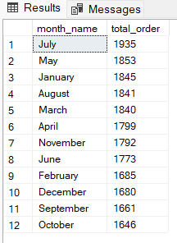

1. Percentage of sales by pizza category:

SELECT pizza_category, sum (total_price) as total_sales, SUM (total_price) * 100 / (SELECT SUM(total_price) from pizza_sales) as pct from pizza_sales GROUP BY pizza_category

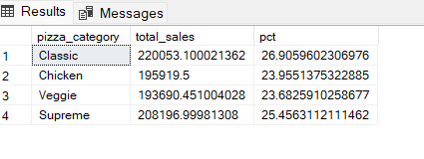

For particular January month =

SELECT pizza_category, sum (total_price) as total_sales, SUM (total_price) * 100 / (SELECT SUM(total_price) from pizza_sales WHERE MONTH(order_date)=1 ) as pct from pizza_sales WHERE MONTH(order_date)=1 GROUP BY pizza_category

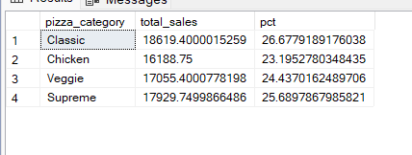

1. Percentage of sales by pizza size:

SELECT pizza_size, CAST(sum (total_price) AS DECIMAL(10,2))as total_sales,CAST( SUM (total_price) * 100 / (SELECT SUM(total_price) from pizza_sales ) AS DECIMAL (10,2)) as pct from pizza_sales GROUP BY pizza_size ORDER BY pct DESC

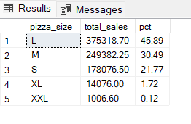

FOR quarter

SELECT pizza_size, CAST(sum (total_price) AS DECIMAL(10,2))as total_sales,CAST( SUM (total_price) * 100 / (SELECT SUM(total_price) from pizza_sales WHERE DATEPART (quarter,order_date)=1) AS DECIMAL (10,2)) as pct from pizza_sales WHERE DATEPART (quarter,order_date)=1 GROUP BY pizza_size ORDER BY pct DESC

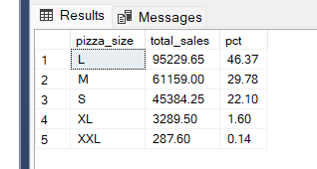

1. Total Pizza sold by pizza category:

SELECT pizza_name, sum(total_price) as total_revenue from pizza_sales GROUP BY pizza_name order by total_revenue DESC

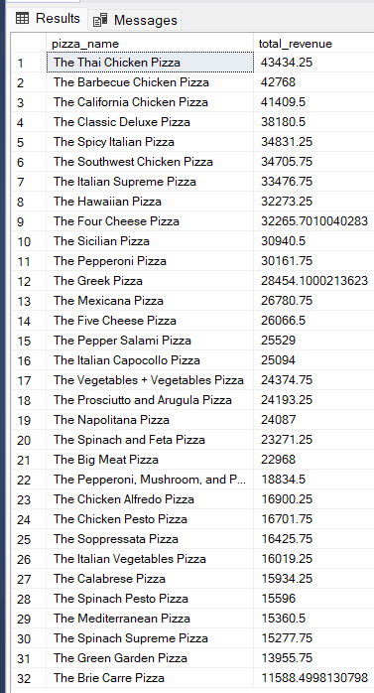

Top 5 pizza:

SELECT TOP 5 pizza_name, sum(total_price) as total_revenue from pizza_sales GROUP BY pizza_name order by total_revenue DESC

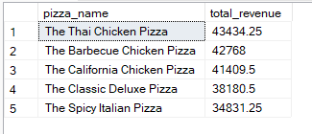

Bottom 5 Pizza:

SELECT TOP 5 pizza_name, sum(total_price) as total_revenue from pizza_sales GROUP BY pizza_name order by total_revenue asc

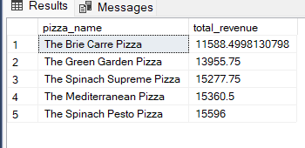

Top 5 best saller:

SELECT TOP 5 pizza_name, sum(quantity) as total_quantity from pizza_sales GROUP BY pizza_name order by total_quantity desc

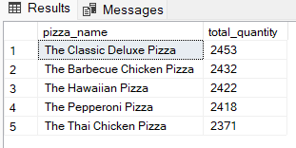

Bottom 5 saller:

SELECT TOP 5 pizza_name, sum(quantity) as total_quantity from pizza_sales GROUP BY pizza_name order by total_quantity asc

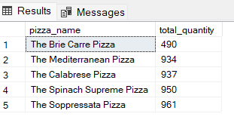

Top 5 best pizza saller with total order:

SELECT TOP 5 pizza_name, COUNT (DISTINCT order_id) as total_quantity from pizza_sales GROUP BY pizza_name order by total_quantity desc

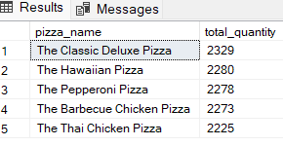

Bottom 5 pizza saller with total order:

SELECT TOP 5 pizza_name, COUNT (DISTINCT order_id) as total_quantity from pizza_sales GROUP BY pizza_name order by total_quantity asc

